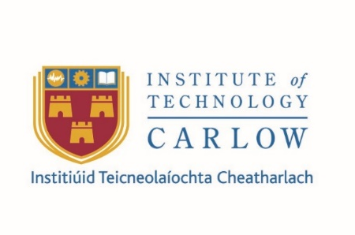
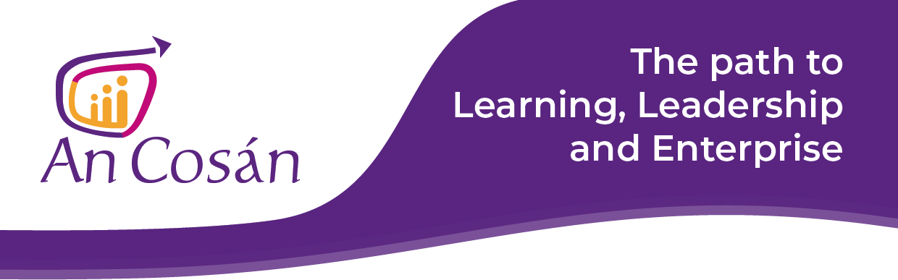
Certificate in Leadership and Community Development
NFQ Level | NFQ Level 6
Duration | 2 Years
Fees | Full Certificate €1,800 or €300 per module.  There are a limited number of funded places available for eligible participants on the MUKISA Programme (eligible applicants include Refugees and Asylum Seekers from outside the European Economic Area.) MUKISA is a programme of Waterford Area Partnership and is funded under the AMIF (Asylum, Migration and Integration Fund), with support from Rethink Ireland.
ECTS Credits | 60
Awarding Body | Institute of Technology Carlow
Next Intake | Autumn 2020
Duration | Duration: Spring 2020 - Summer 2022

Please note: information given is accurate at the time of publication but subject to revision. Programmes will only run where viable.

Programme Overview

An Cosán VCC in partnership with IT Carlow has developed a blended online Bachelor of Arts (BA) in Leadership and Community Development (QQI Level 7). Learners who complete Stage 1 at Level 6 of the NFQ (60 credits) are eligible to exit the programme with a “Certificate in Leadership and Community Development” (Minor Award Level 6) or to progress to Higher Certificate (QQI Level 6) and BA Degree (QQI Level 7) awards.
Aim of Programme
The aim of this interdisciplinary 2 years blended online certificate programme is to develop student’s comprehensive knowledge and understanding of the theory, concepts and structures associated with leadership and community development so that they can research, identify, implement, practice and evaluate appropriate interventions for change and advance their own communities.

Delivery Format
The Certificate in Leadership and Community Development is being offered fully online for the 2020-2021 academic year. All modules will be delivered in online environments, through a combination of live and recorded lectures, online discussions and forums, as well as individual and group assignments. Teaching will be facilitated through An Cosán’s and IT Carlow’s online learning environment, Blackboard, the Zoom video platform, and other tools. In order to participate in the programme, students are required to have access to a desktop or laptop computer and a reliable internet connection.

Subject to public health advice, should the restrictions around in person delivery of teaching change, some sessions may take place in Waterford or in a blended mode combining in-class and online engagement. However, students who are unable to join face-to-face workshops will be able to complete their Certificate fully online.

The online programme is delivered by the same high quality and experienced staff who traditionally deliver in person and online education. Educators will provide feedback on your assignments and you will have access to staff via email or Zoom video calls to discuss your work. The above conditions are subject to government and public health advice regarding restrictions and social distancing measures and may be modified or adapted as the situation changes.

The Certificate’s Orientation Day will take place online on Monday 2nd November (10am-1pm). Students will be introduced to one another, to course content, and to online learning. Each 10 ECTS Credits module will consist of 8 online sessions, Mondays (10am-12:30pm). Additional tutorial sessions in the online classroom may be offered throughout the year to assist students with study skills and assignments.

Modules

Module # | Title | Draft Schedule
Module 1 | Learning to Learn at Third Level (Cohort 1) | February – March 2020
 | Learning to Learn at Third Level (Cohort 2) | TBC
Module 2 | Introduction to Community Development | 2nd November – 14th December 2020
Module 3 | Social Analysis | January – March 2021
Module 4 | Group Work and Facilitation Skills | April – June 2021
Module 5 | Introduction to Community Leadership | September – December 2021
Module 6 | Citizenship and Social Action | January – March 2022

*All 6 programmes above are included in the Certificate but the order in which they run may vary.
Participants are required to attend two Face to Face workshops for each module.

Teaching, Learning and Assessment
Students will acquire in-depth knowledge and develop research and problem-solving skills through work and enquiry-based learning, more formally structured tuition, and self-directed learning. They will develop competencies in the following transferable skills: written and oral communication, critical thinking, digital literacy, group collaboration, problem solving, planning & time management. A variety of assessment methods such as reflective journals, presentations, research projects, portfolios and assignments are used on the programme.
Learner Supports

At VCC, we support our learners fully so that they can achieve their full potential.

• Technology moderators provide technical support and encouragement to learners in advance of and during online sessions.

• Qualified tutors with in-depth classroom experience and subject matter expertise are readily available to discuss programme content.

• One-to-one online mentors are available throughout the programme.

• Learners are actively encouraged to support one another and build collaborative learning communities.
Time commitment
For each accredited programme (6 modules), you need to be available for two full day workshops (2 x 6-hour face-to-face workshop) and 8 online sessions (2.5 hours per week). It is recommended that participants allocate 3 hours per week for self-directed study to cover suggested readings and videos.
Entry Requirements
Applicants must be 18 years+. Applicants should have completed the Leaving Certificate or a QQI (FETAC) Major Award at Level 5 preferably in the area of leadership, community development studies or a related area. Other applicants will be considered on a case-by-case basis in accordance with the Institute of Technology Carlow policy on recognition of prior learning (RPL). Applicants may be required to attend for an interview.
Applicants whose first language is not English must provide evidence of English language proficiency (i.e. IELTS or TOEFL certificate of English language proficiency).
Admissions
We are currently receiving applications for programmes commencing in Autumn 2020. Places are limited and will be allocated on a first come basis.
Fees
Full Certificate €1,800 or €300 per module.
There are a limited number of funded places available for eligible participants on the MUKISA Programme (eligible applicants include Refugees and Asylum Seekers from outside the European Economic Area.) MUKISA is a programme of Waterford Area Partnership and is funded under the AMIF (Asylum, Migration and Integration Fund), with support from Rethink Ireland.
For more information and to register a place contact:

Community Partner: Michelle McQuaid / Sue Larkin, Coordinator on the Mukiso Programme, Waterford Area Partnership on Email: amif@wap.ie or mobile 086 600 3828.

Or contact Maria Flanagan, Community Partner Lead, An Cosán on mobile 086 8223808
An Cosán Contact details: Phone 01 462 8488 or email info@ancosan.ie Web: www.ancosan.ie

