C2360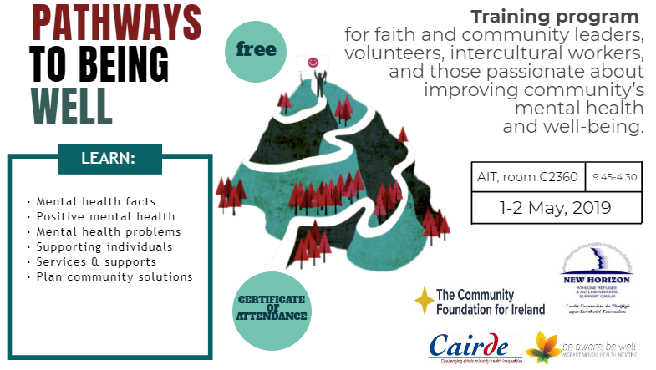

Booking form
Name:……………………………………………………………
Phone:…………………………………………………………
Email:……………………………………………………………
Athlone Institute of Technology, room C2360
1-2 May 9.30-4.30pm

Email completed Booking Form to mentalhealth@cairde.ie as soon as possible

What is your present work or volunteer work that will be enhanced by Pathways to Being Well training?

……………………………………………………………………………………………………………………………………………………………………..

………………………………………………………………………………………………………………………………………………………………………

………………………………………………………………………………………………………………………………………………………………………

Are you committed to attending all four of the scheduled sessions? ……………………………………………….

Do you need support with travel and childcare costs in order to participate? …………………………………

